

Article for “Charitable Returns”

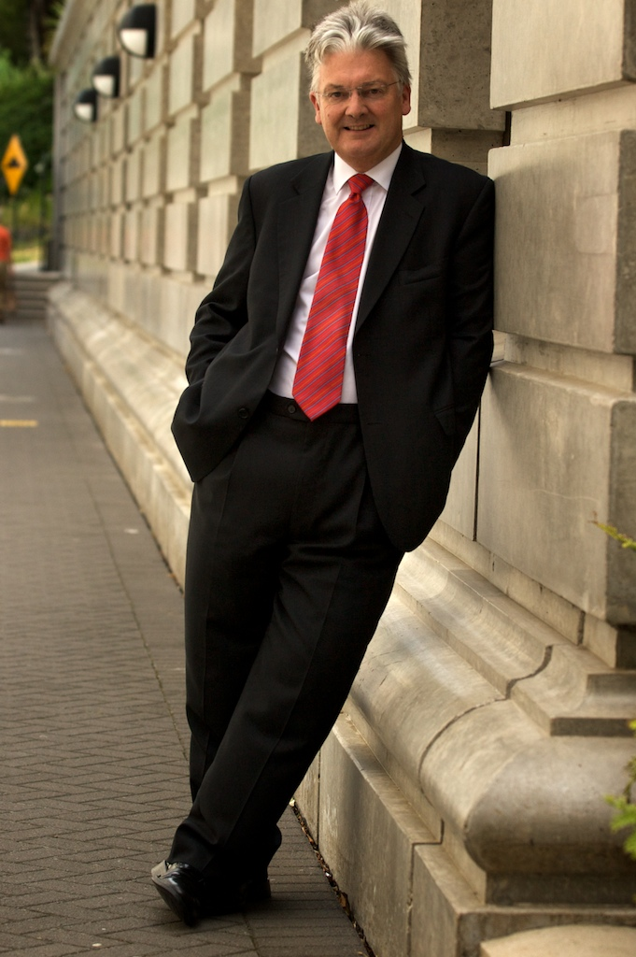
Few New Zealanders would be unaware of the current turmoil in world financial markets as a result of the ‘sub-prime mortgage’ disaster and the resultant credit crunch.

Because New Zealand is an open economy, subject to all the disciplines that come with dealing with the globalised world, it is relevant for Kiwis to look to their savings and their investment strategies in order to protect their capital, often their life savings.

The New Zealand Government’s role in assisting with this is to try to improve the national savings environment through the introduction of KiwiSaver – already half a million Kiwis have joined – and through changes to the tax regime, such as the lowering of company tax to 30%, the well-signalled changes to personal tax rates that will be announced in the upcoming Budget, and the massive changes in taxes affecting charitable donations.

The latter changes may not result in money going straight to people’s pockets, but the expected boost to New Zealand society will make immeasurable improvements to the quality of life of all New Zealanders.

I would also make the point that the new PIE arrangements have the potential to provide very big benefits to New Zealanders looking to save their money.

Wearing my hat as leader of UnitedFuture, I want to see longer-term improvements to the tax system under the 30:30:30 system, i.e. 30% top personal tax rate; 30% company tax; and 30% trust tax rate.

The net effect of such changes, in my view, would leave New Zealanders with more of their own money in their own pockets to make their own decisions about how they spend, or save, it.

ends

Contact: Ted Sheehan
021 638 920

